# BISMILLAH HIR RAHMANIR RAHIM

School MANAGEMENT SYSTEM

BY

# C143061

# C143065

# C143074

# C143076



DEPARTMENT OF COMPUTER SCIENCE AND ENGINEERING INTERNATIONAL ISLAMIC UNIVERSITY CHITTAGONG 05/10/2017

DONE BY:

# C143061

# C143065

# C143074

# C143076

A PROJECT REPORT SUBMITTED IN PARTIAL FULFILLMENT OF THE REQUIREMENT FOR THE

DEGREE OF BACHELOR OF SCIENCE IN COMPUTER SCIENCE AND ENGINEERING

DEPARTMENT OF COMPUTER SCIENCE AND ENGINEERING INTERNATIONAL ISLAMIC UNIVERSITY CHITTAGONG

#### A Project Report Submitted by

**Tarek Aziz C143061**

**Md. Amir Hossain C143065**

**Md. Sazzad Hossain C143074**

**Muhammad Toha Bin Islam C143076**

#### For the partial fulfillment of the degree of

B. Sc. in Computer Science and Engineering Examination held on 23rd September, 2017

**Approved by:**

#### Md. Arif Hasnayeen

**Supervisor**

Lecturer

Department of Computer Science & Engineering International Islamic University Chittagong

DECLARATION

This to declare that the project on School Management System is the original work done by C143061 (Matric), C143065 (Matric), C143074 (Matric) and C143076 (Matric) during this project submission as a partial fulfillment of the System Design And Analysis Sessional Project of B. Sc in CSE 6th semester, of the International Islamic University Chittagong. This project is not copied or taken from anyone else.

C143061

C143065

C143074

C143076

DEDICATION

We would like to dedicate the project on School Management System to our respective parents, teachers for the support and help they have always given us.

ACKNOWLEDGEMENT

First of all, we express our gratitude to the Almighty Allah (S.W.T). By the mercy of Allah (S.W.T) we have completed our Project successfully.

#### We feel profound gratitude to our supervisor Md. Arif Hasnayeen, International Islamic University Chittagong for his every support and advice.

We, hereby express our profound gratitude, thanks and appreciation to **Mr. Md. Arif Hasnayeen** our **System Analysis And Design (CSE-3608)** course teacher for his constant inspiration, encouragement and guidence and direction throughout the execution of this project and without who’s valuable support this project would not

have had the desired affect.

C143061

C143065

C143074

C143076

ABSTRACT

This project deals with the automation of the School Management. This project implementation is based on HTML as frontend and PHP, MYSQL as backend the main function of this system are Head teacher, teachers and students. It has been developed with an user friendly interface such as students registration, registration of new student and other teacher accounts etc. The software is also able to manipulate and process data. This software has been developed for recording the data efficiently and store easily in the database.

TABLE OF CONTENTS

ACKNOWLEDGEMENT

1. INTRODUCTION OBJECTIVE

OVERVIEW OF PRESENT SYSTEM

PROJECT SCOPE PROJECT DELIVERABLES

1. FEASIBILITY STUDY GANTT CHART FEASIBILITY STUDY
2. METHODOLOGY
3. EVALUATION CRITERIA
4. ACTIVITY DIAGRAM
5. SYSTEM DESIGN

ENTITY RELATIONSHIP DIAGRAM (ERD)

ERD WITH ATTRIBUTE

NORMALIZATION

DATABASE TABLE

RELATIONAL SCHEMA

1. DATA FLOW DIAGRAM (DFD)
2. USE-CASE DIAGRAM
3. SEQUENCE DIAGRAM
4. IMPLEMENTATION AND CODING

10.1 IMPLEMENTATION

10.2. SNAPSHOTS

1. TESTING
2. LIMITATION
3. CONCLUSION
4. BIBLIOGRAPHY

# LIST OF TABLES AND FIGURES

**FIGURES**

Fig 2.1: Gantt Chart

Fig 6.2: ERD with attribute Fig 6.3: Relational Schema Fig 7.1: Context Diagram

Fig 7.2: Level-0 DFD

Fig 8.1: Use Case Diagram

Fig 9.1: Sequence diagram

**TABLES**

4.1: Project Requirement

* 1. : all_User
  2. :coursereg
  3. : course

# INTRODUCTION

In this project an analysis has been made on the school result System. It is tried that the result system could be managed by with in the system. It is tried that the users feel easy and comfortable to use the system. The system is tries to keep a record of the student of the school management, the software also enables to update and delete the record, the software also provides the user activation facility, student can be activated by their teacher or by the Head teacher.

* 1. OBJECTIVE

-The software is for the automation of the school result Management

* + - It maintains only three levels of user: 1. super administrator, 2. administrator, 3. user.
    - The software includes:
      * User wise Authorized access to system
      * Different user can perform different set of operation
      * Active user for the system
      * Non active user for the system
  1. OVERVIEW OF PRESENT SYSTEM

The present system consists of features such as registration, add, update, delete, activation user information. The present system also consists of authorized view, such as super admin can, delete, add, update, view all database. Teacher can do what Head Teacher does except delete. Student only can view his/her CGPA. The present system also maintains Activation system e.g. only activated student can view their CGPA

* 1. PROJECT SCOPE

It can be used in any school, university, college only for publishing initial result

* 1. PROJECT DELIVERABLES

Project is related to school result managment System with the following features: **Registration:**

On the system the Head Teacher, Teacher can register someone

**Activation system:**

Only activated student can view their result. Teacher and head teacher can activate student

**Update**

Both teacher and Head Teacher can update

**Delete:**

Only head teacher can delete

**School calendar:**

Show a static school calendar

**School result:**

Show a the previous year success results

**Add delete update courses:**

Teacher HeadTeachere can add delete update the add courses

**Student wise taken course show:**

Each student view their taken courses

**Dress code:**

Show dress code information

**School Admission**

Static show of admission rules in school

**News and other routine:**

Show routine pdf link. And also show news about different program

**Quick overview of school:**

Gives a quick overview of the school by discussing history, back gourd of school.

**Notice board:**

Give a static notice board at homepages

**School Magazine:**

For the entertainment purpose school magazine also published in static mode

**Guest user facility:**

Guest user can’t watch result. But he can have idea about the school. With all above static element

# FEASIBILITY STUDY

* 1. GANTT CHART

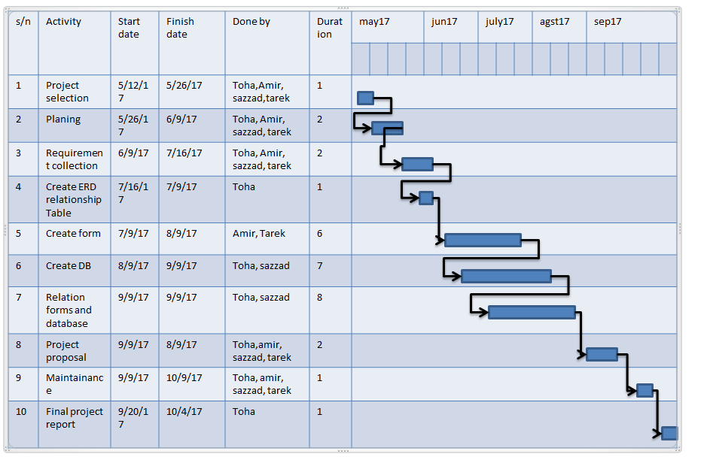

* 1. FEASIBILITY STUDY

Feasibility study is a test of system proposal according to its workability, impact of the organization, ability to meet needs & effective use of resources.

During feasibility analysis for this project, following primary areas of interest are to be considered. Investigation & generating ideas about a new system does this.

Steps in feasibility analysis

* For a project team.
* Prepare system flowchart.
* Enumerate potential proposed system.
* Defined & evaluate perf
* ormance & cost effective of each proposed system.
* Select best proposed system.
* Prepare and report final project direct to management.
  + 1. TECHNICAL FEASIBILITY

A study of resources availability that may affect the ability achieve an acceptable system. This evaluation determines whether the technology needed for the proposal system is available or not.

The technical needs of the system may include: Front end selection

1. Feasibility
2. Robustness
3. Easy to debug and maintain
4. Must have a GUI that assists user who is not from IT background
5. Scalability and extensibility

We have selected HTML as our front end. Back end selection

Efficiently data handling

1. Efficient data retrieval and maintenance
2. Easy to install
3. Compatible

We have selected PHP, MYSQL as our back end.

#### Economic Feasibility

Economic consideration is generally the “Bottom Line” consideration for most systems. Economic justification includes a broad range of concerns that includes cost benefit analysis. In this we weight the cost and the benefits associated with the candidate system and if it suits the basic purpose of the organization i.e. profit making, the project is making to the analysis and design phase.

The financial and economic questions during the preliminary investigation are verified to estimate the following:

The cost to conduct a full system investigation.



The cost of hardware and software for the class of application being considered. The benefits in the form of reduced cost.



This feasibility checks whether the system can be developed with the available funds. The Hospital Management does not require enormous amount of money to be developed. This can be done economically if planned judicially, so that it is economical feasible.



#### Operational Feasibility

It is mainly related to human organizations and political aspects. The points to be considered are:

What changes will be brought with the system? What if organization structures are disturbed?



What new skills will be required? Does the user have the skills? If not, can they be trained in due course of time?



The system is operationally feasible as it is easy for the End users to operate it. It only needs the basic information about Windows platform.

#### Schedule Feasibility

Time evaluation is the most important consideration in the development of project. Time schedule required for the development of this project is important since more development time effect machine time, cost and cause delay in the development of other systems.

A reliable Hospital Management System can be developed in a considerable amount of

time.

* 1. Methodology

To make a software, developers have to follow some methodology. In our project we follow **SDLC** methodology. Because using this method we can do our job step-by-step & schedule wise. **SDLC** is a process of understanding how an information system can support business needs, designing the system, building it and delivering it to users.It includes five steps. These are:

##### Planning

* + 1. **Analysis**
    2. **Design**
    3. **Logical Design**
    4. **Physical Design**

##### Implementation

* + 1. **Maintenance**
  1. EVALUATION CRITERIA

4.1 PROJECT REQUIREMENTS

|  |  |  |  |
| --- | --- | --- | --- |
| **Hardware Requirements** | | | |
| Processor | RAM | | Disk Space |
| Pentium II, Pentium III Pentium IV, or higher version | 64 Mb or higher | | 130Mb |
| **Software Requirement** | | | |
| Operating System | | Database | |
| Win-98, Win-XP, Win-7, Linux or any other higher version | | MySQL | |

# ACTIVITY DIAGRAM

Activity diagrams are graphical representation of workflows of stepwise activities and action with support choice, iteration and concurrency.

Construction:

Activity diagrams are constructed by the following shapes:

Start (initial state) end (final state)

Activities Concurrent activities

Current activity Fork concurrent start Joint concurrent finish



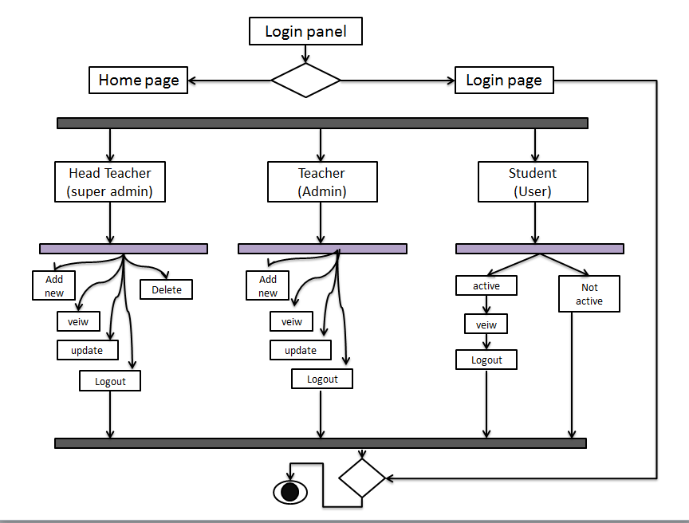

Fig: 5.1activity diagram

# SYSTEM DESIGN

* 1. ENTITY RELATIONSHIP DIAGRAM (ERD)

Entity-relationship model (ER model) is an abstract and conceptual representation of data. ER modelling is a database modelling method used to produce a conceptual schema or semantic data model of a system, often a relational database and its requirements in a top-down fashion. Diagrams created by this process are call enitity- relationship diagram (ERD).

ER diagrams are constructed by the following shapes:

Attribute Relationship Entity Set Connector

* + 1. RD WITH ATTRIBUTES

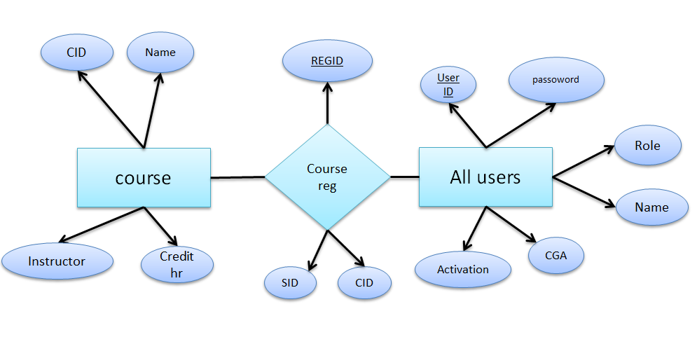

Fig 6.1: ERD with attribute

* 1. RELATIONAL SCHEMA

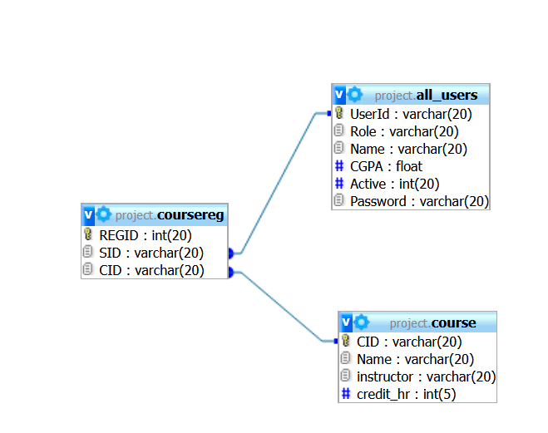

Fig 6.2: Relational Schema

* 1. DATABASE TABLES

All_users

|  |  |
| --- | --- |
| **Variable Name** | **Variable type** |
| userID | Varchar(20) |
| Role | Varchar(20) |
| Name | Varchar(20) |
| CGPA | Float |
| Active | Int(20) |
| password | Varchar(20) |

courseReg table

|  |  |
| --- | --- |
| **Variable Name** | **Variable type** |
| REGID | Int(20) |
| SID | Varchar(20) |
| CID | Varchar(20) |

Course table

|  |  |
| --- | --- |
| **Variable Name** | **Variable type** |
| Cid | Varchar(20) |
| name | Varchar(20) |
| Instructor | Varchar(20) |
| Credit_hr | Int(5) |

* 1. DATA FLOW DIAGRAM

7.1 CONTEXT DIAGRAM

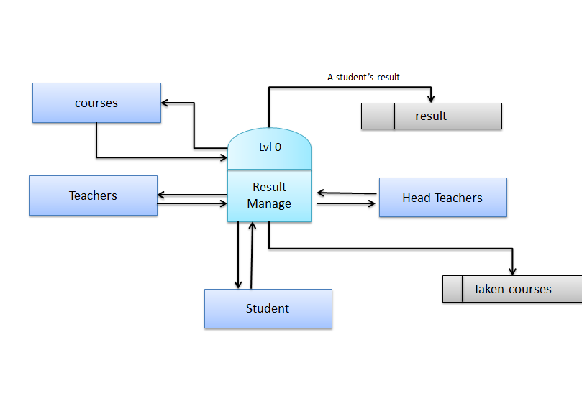

 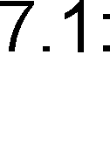 **context diagrame of school management system**

7.2 Level-0 DFD

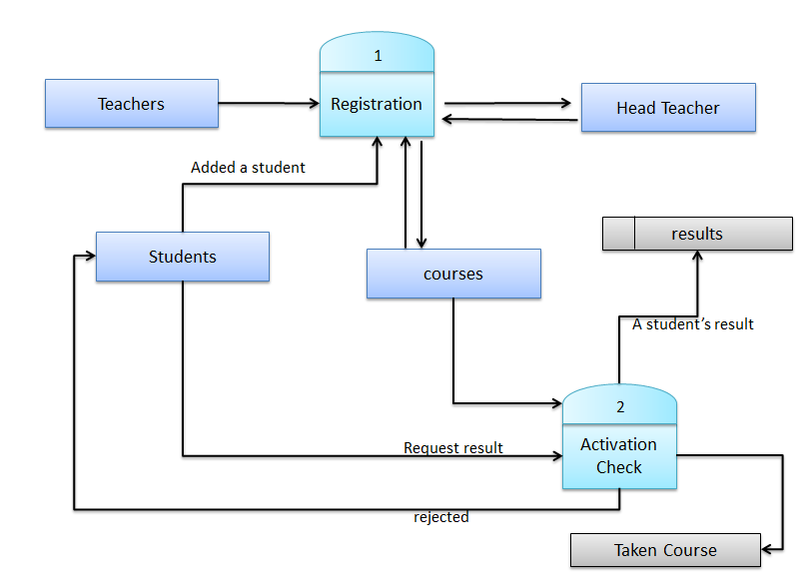

Fig 7.2: Level-0 DFD

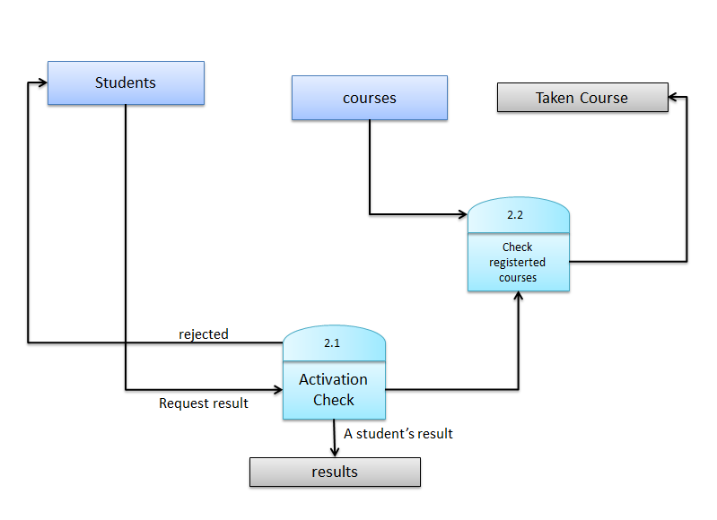

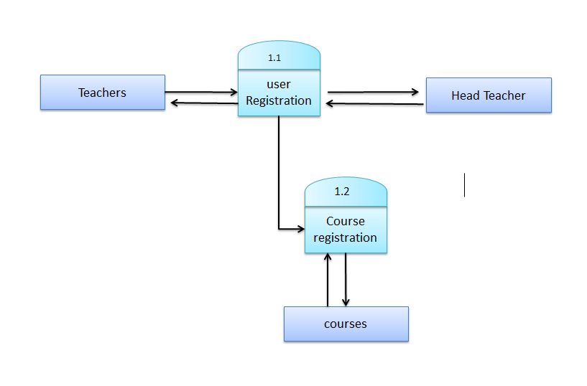

# USE CASE DIAGRAM

# 

# Fig8.1 use case diagrame

# SEQUENCE DIAGRAM

A sequence diagram is shows how processes operate with one another and in what order. It is a construct of a message sequence chart. A sequence diagram shows object interactions arranged in time sequence. It is depicts the objects and classes involved in the scenario and the sequence of messages of exchanged between the objects needed to carry out the functionality of the scenario. Sequence diagram are sometimes called event diagrams.

9.1 login

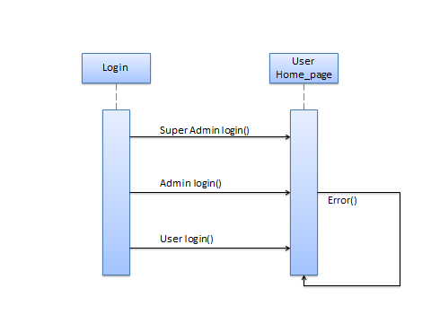

9.2 Super Admin ( Head Teacher)

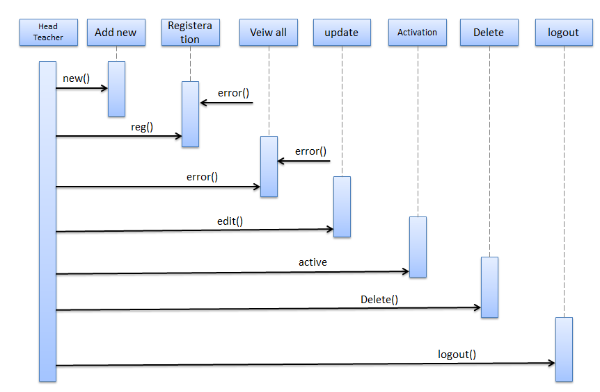

9.3 Admin (Teacher)

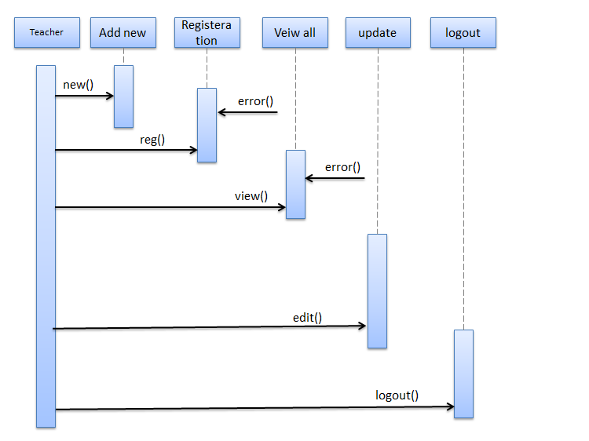

9.4 User (Student)

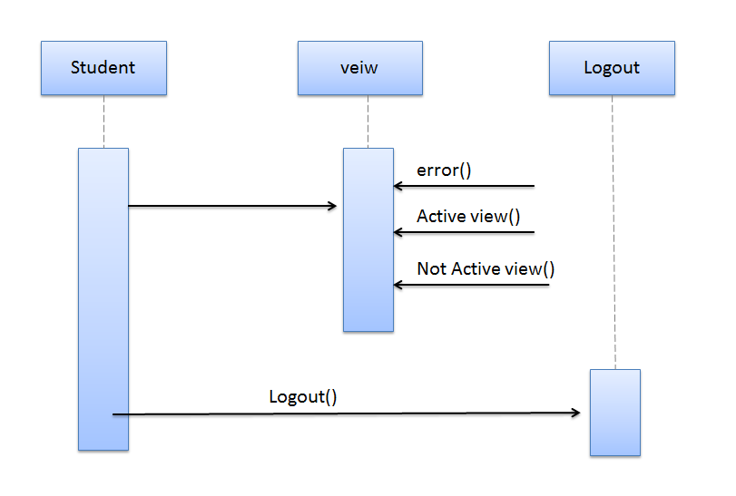

9.5 Activation

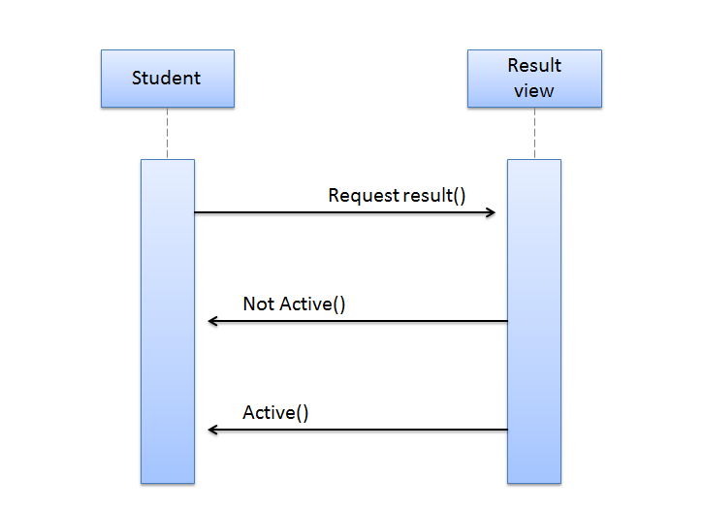

10. IMPLEMENTATION AND CODING

* 1. SOFTWARE IMPLEMENTATION

We implement our software using given below

* + - PHP
    - HTML
    - CSS
    - MYSQL
  1. Snapshot

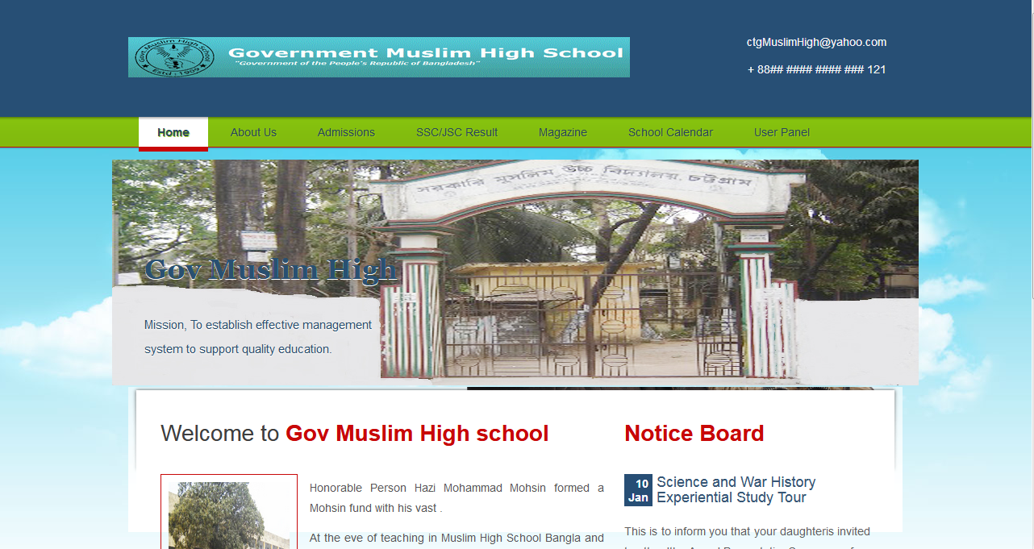

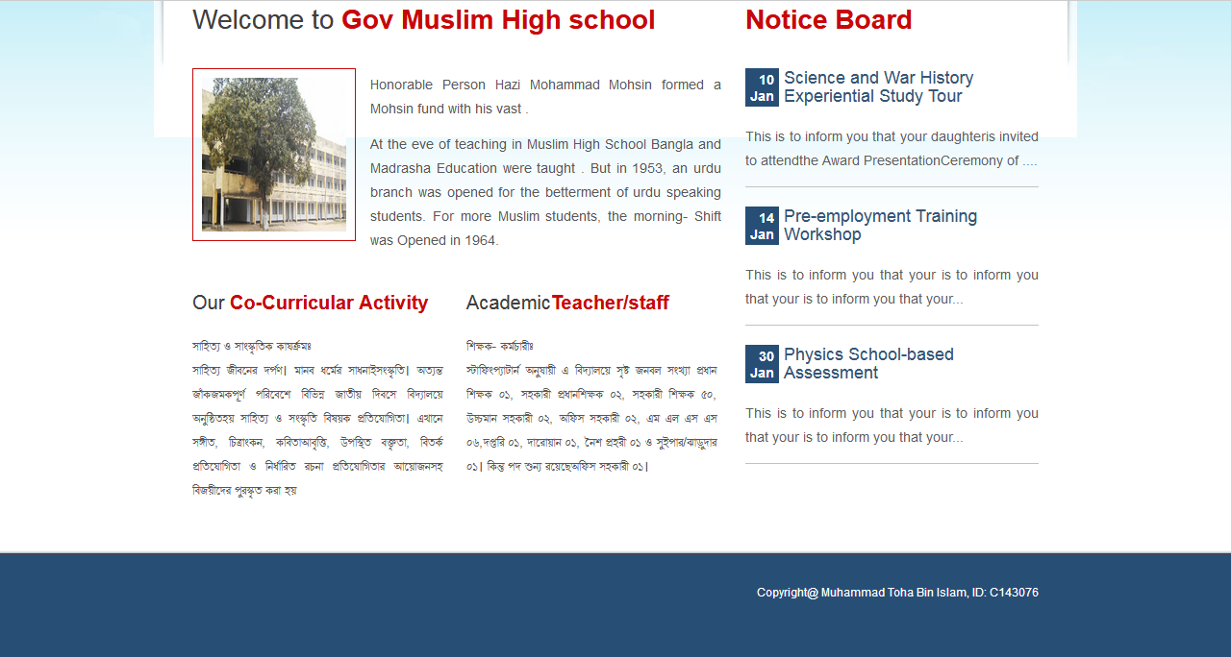



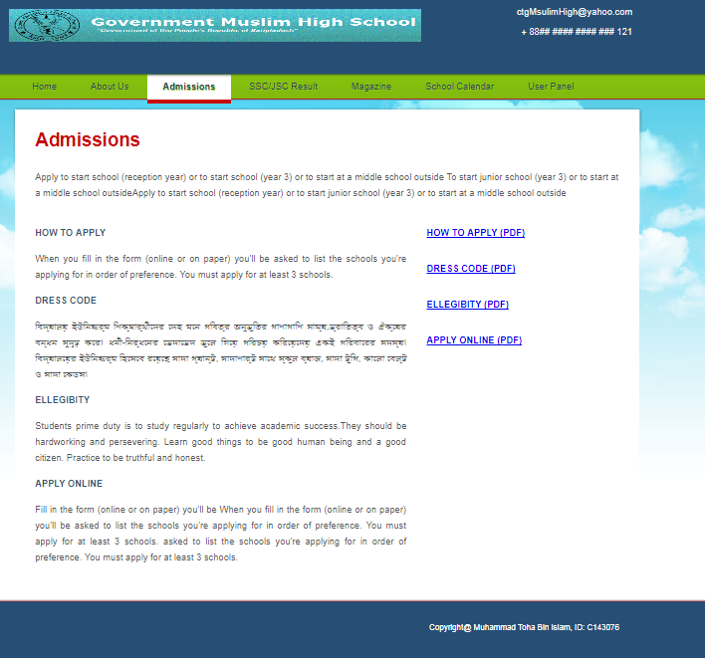

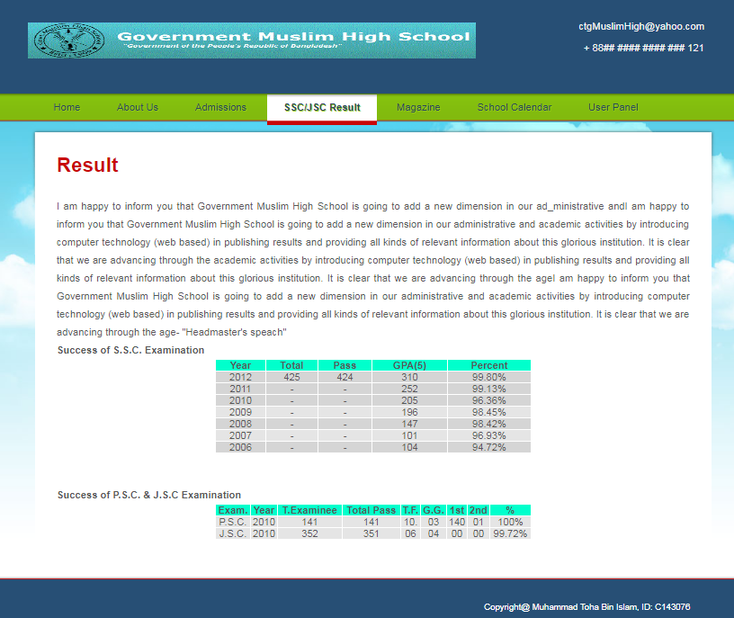

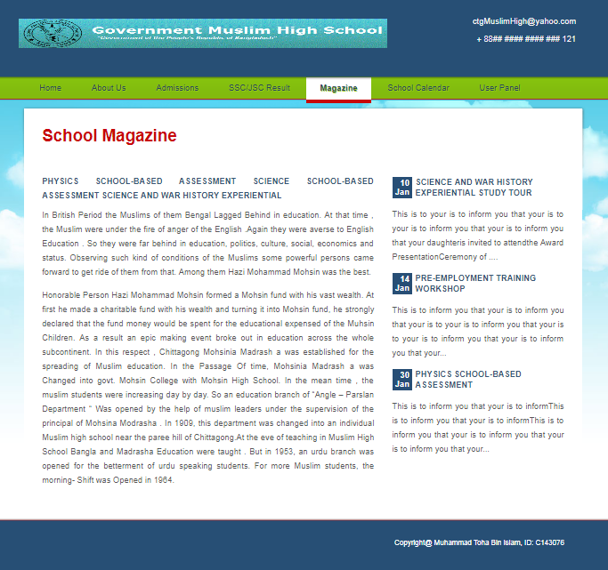

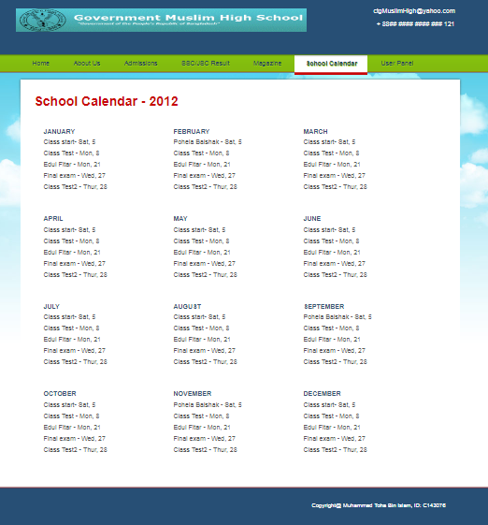

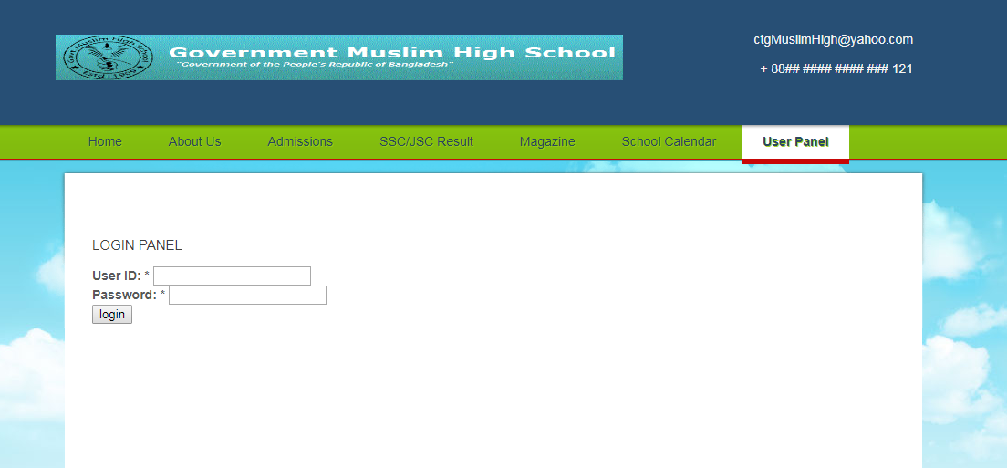

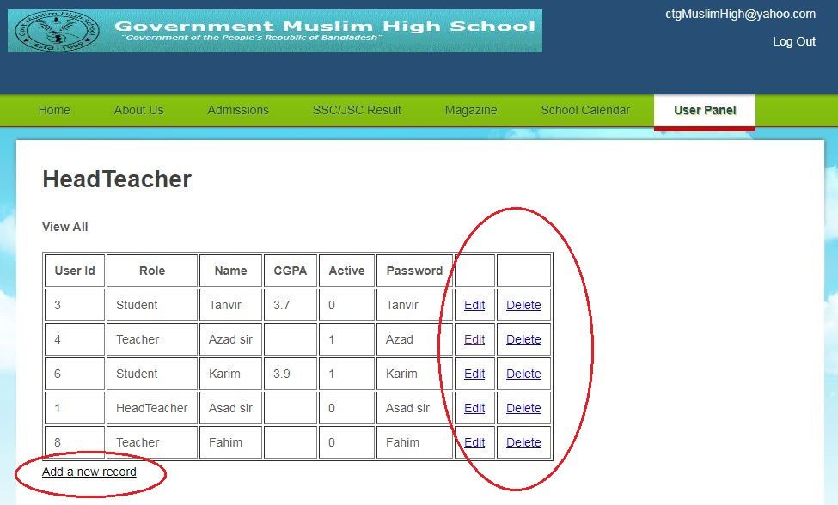

EDIT

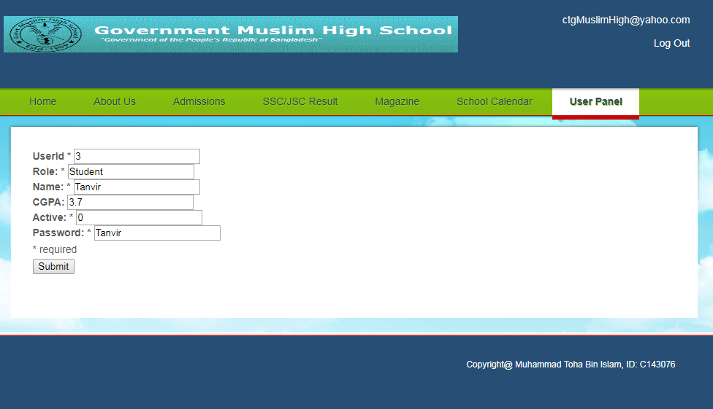

ADD

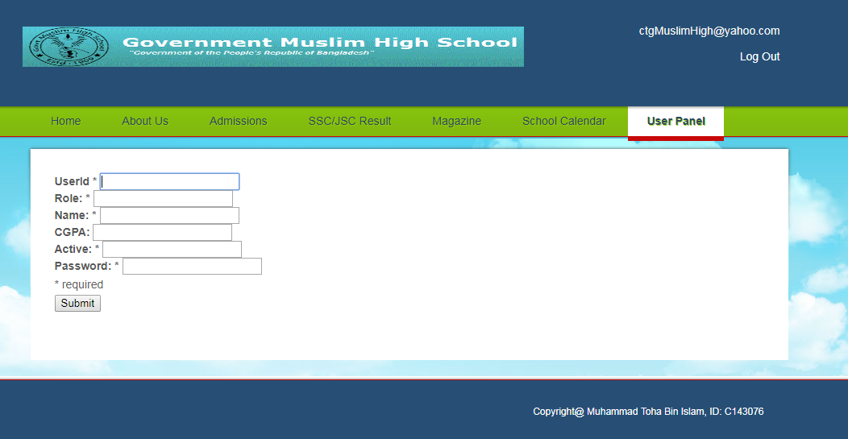

Admin (teacher)

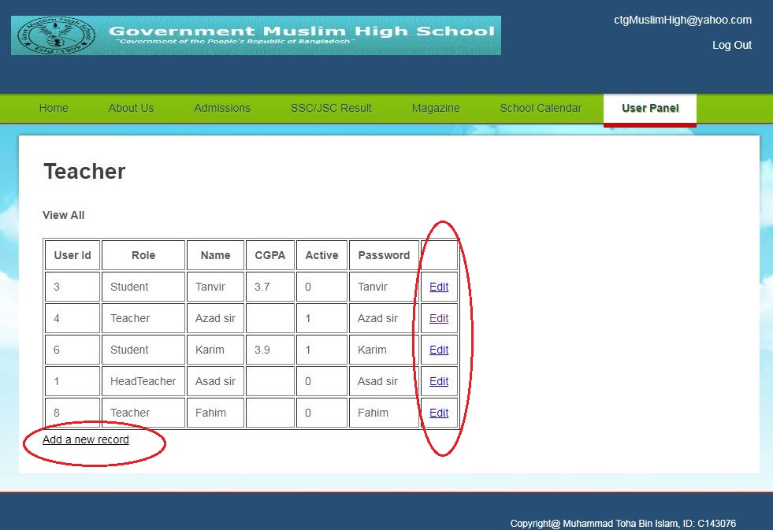

Not Active user

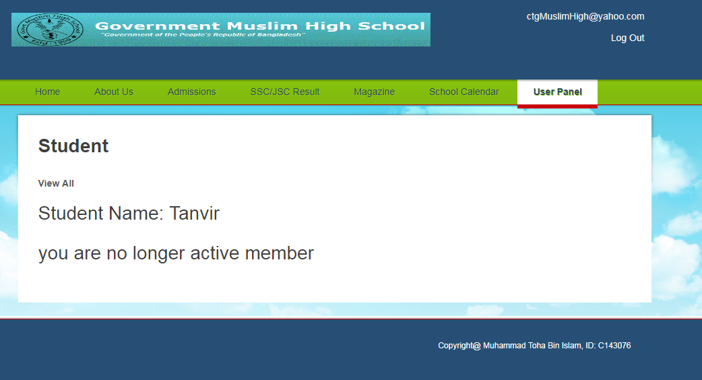

Active user

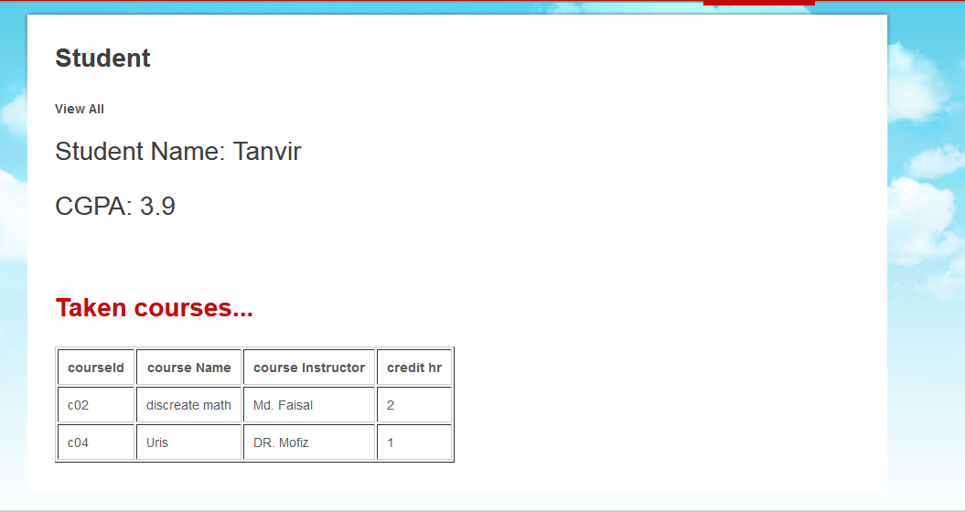

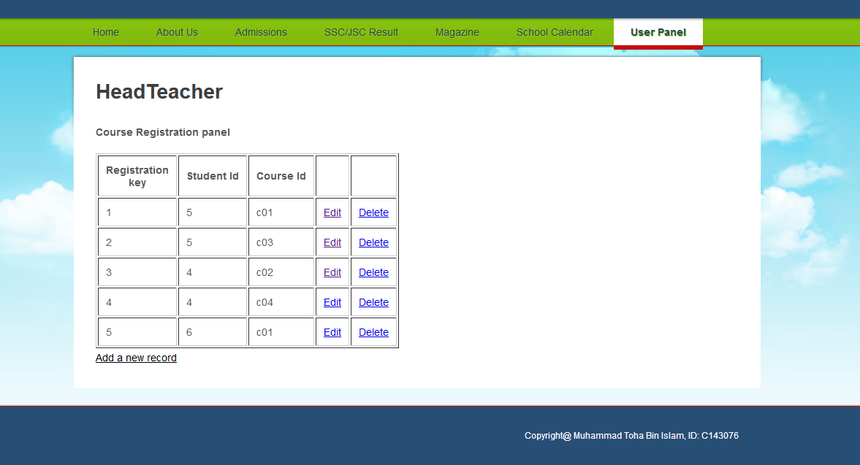

Add registretion

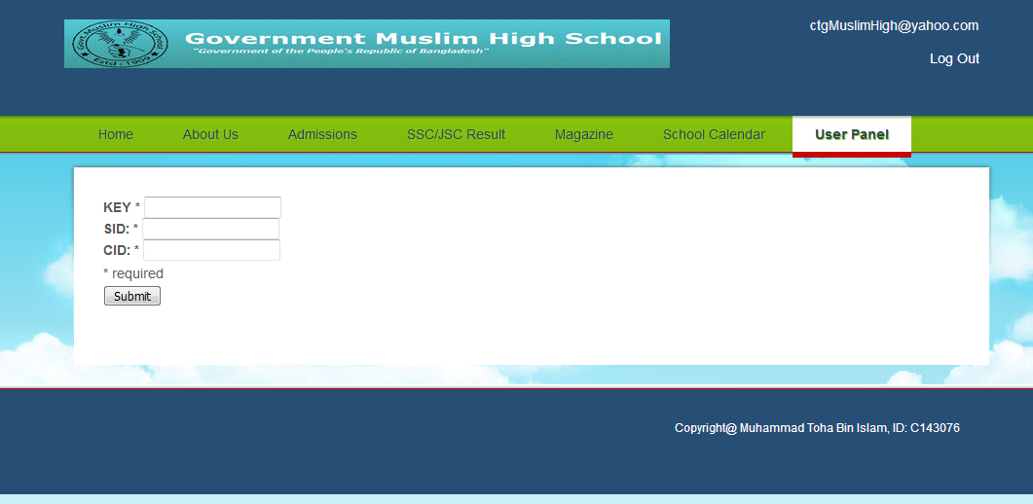

# TESTING

**Testing :** It is a process to check the system either any error occurs or not.There are four methods of testing are exist.These are :

* **Unit Testing :** Each module is tested alone in an attempt to discover any errors in its code. It is Two types :

1. **Black Box testing :** The tester focuses on whether the unit meets the requirments stated in the program specification.
2. **White Box Testing :** It looks inside the program to test its major elements.
   * 1. **Integration Testing :** It is the process of bringing together all modules that a program comprises for testing purposes.There are four types of integration testing :
   1. **User Interface Testing :** The tester test each interface function.
   2. **Use Scenario Testing :** The tester test each use senario.
   3. **Data Flow Testing :** It test each process in a step-by-step fashion.
   4. **System Interface Testing :** It test the exchange of data with other systems.
      1. **System Testing :** It is the process of bringing together all of the programs that a system comprises for testing purposes.There are five types of system testing :
   5. **Requirements Testing :** It test whether original business requirements are met.
   6. **Usability Testing :** Test how convenient the system is to use.
   7. **Security Testing :** Test disaster recovery and unauthorized access.
   8. **Performance Testing :** Examins the ability to perform under high loads.
   9. **Documentation Testing :** It test the accuracy of the documentation.
      1. **Acceptance Testing :** Actual user test a completed information system. There are four types of acceptance testing :
   10. **Alpha Testing :** Conducted by users to ensure they accept the system.
   11. **Beta Testing :** Users closely monitor the system for errors or useful improvements.

# LIMITATIONS

* 1. USER CHARACTERISTICS

Every user should be:

* Comfortable of working with computer.
  1. CONSTRAINTS
* GUI is only in English.
  1. PROBLEMS WITH CONVENTIAL SYSTEM
* It only show the students CGPA
* It don’t show student full result
* Print facility could not be provided.

.

# CONCLUSION

**Conclusion :** The project school reslut management is for displaying student result. The software takes care of all the requirements of an average school and is capable to provide easy effective storage of information related to result that come up to the school.

# BIBLIOGRAPHY/ REFERENCES

[www.google.com](http://www.google.com/)  [www.w3schools.com](http://www.w3schools.com/)



Begining PHP6, Apache MySQL webdevelopement - Boronczyk, Naremore, Gener



Code pen , themforest

Multimedia And webtechnology -Nukesh KumarGurpeel Kaur.

